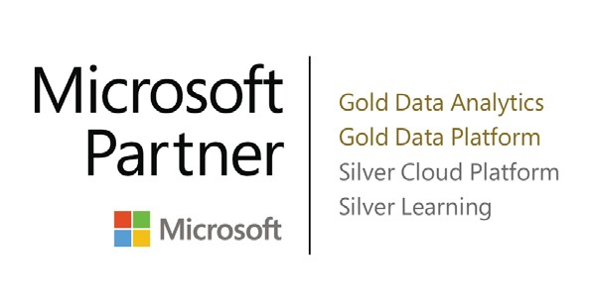

**Course Code:** PBIA

**Course Duration:** 1 Day

**SATV**: No

Course Summary

Module 1: Querying Data with Power BI

Module 2: Working with DAX

Module 3: Advanced DAX

Module 4: Advanced Visualisations

Course Pre Requisites

Before attending this course participants must have:

* Attended the Power BI Essentials course or have equivalent knowledge
* An understanding of the data being accessed and how you want to display that data
* Basic experience writing Excel Formulas
* Some exposure to Power BI or Excel data modeling

What to Bring

**This is a BYO device course:**

* Please bring along your laptop or device to access the virtual lab environment

Who Should   
Attend

This course is intended for all types of experienced Power BI users and developers including server and content managers, designers, and developers who are responsible for the design, implementation, and maintenance of reporting in Power BI.

This includes:

* Database developers and administrators who want to create and evaluate modern data analytics solutions
* Business Intelligence developers looking to modernise skills for the cloud

This one-day hands-on course covers advanced techniques in development of Power BI reports and dashboards using the Power BI Desktop and the online Microsoft Power BI portal.

The course provides an overview of the advanced features of Power BI, which includes query techniques using the M query language, building on sophisticated time intelligence functions using DAX and other advanced modelling techniques to support innovative visualisations in Power BI.

Throughout this course, the attendee will gain extensive experience creating and managing reports using real-world, commercial scenarios in Power BI.

Module 3: Advanced DAX

This module shows you how take the modelling language of DAX to a new level. Here we will cover all the remaining advanced topics including time intelligence and working with advanced filter context.

* Lesson 1: Evaluation Contexts and Relationships
* Lesson 2: Working with iterators
* Lesson 3: DAX Time Intelligence
* Lesson 4: Budget and Actuals
* Lesson 5: Performing What If? Analysis in DAX

**Lab 3: Advanced DAX**

Module 4: Advanced Visualisations

This module includes various dashboards design and report patterns implementing best practices for authoring compelling reports and dashboards for business users.

* Lesson 1: Digital Storytelling
* Lesson 2: Bookmarks and Buttons
* Lesson 3: Enhancing visuals using DAX
* Lesson 3: Using Advanced custom visuals
* Lesson 4: R Integration

**Lab 4: Advanced Visualisations**

Module 5: Power BI Administration

This module covers the administration of Power BI. Which includes configuring a data gateway for on-premise data refresh and discussing the advantages and limitations of adopting a direct query approach.

* Lesson 1: Data Refresh
* Lesson 2: Direct query and Live connections
* Lesson 3: Administering a Power BI tenant

**Lab 5: Optional**

Course Outline

Introduction

This module is designed to introduce you to the larger Power BI environment in which business is conducted, by building on the knowledge and experience gained in the Power BI Essentials course.

* Introductions
* Course overview

Module 1: Querying Data with Power BI

This module introduces you to how the M Power Query language can be used to extend the standard data extraction and transformation capabilities in Power BI.

* Lesson 1: Introduction to M
* Lesson 2: Parameterised Queries
* Lesson 3: Query Folding
* Lesson 4: Using R as a data source

**Lab 1: Querying Data with Power BI**

Module 2: Working with DAX

This module introduces the power of DAX modeling language to turbo charge your Power BI solutions. It starts with an existing Data Model and then progresses towards building a multitude of common functions to enhance and optimize the model for reporting.

* Lesson 1: DAX Overview
* Lesson 2: Using variables
* Lesson 3: Using Tables
* Lesson 4: Querying with DAX
* Lesson 5: Hierarchies in DAX

**Lab 2: Working with Data Analysis Expressions**